Record No: 0682
WILLIAM BARNARD REGINALD BELLINGHAM SOMERVILLE (Bill)

of Rossana Cottage, Rathnew, Co Wicklow; subsequently Dargle Hill, Enniskerry, Co Wicklow.

Son of Reginald Malcolm John Bellingham Somerville (0670) and Honor Lucretia Philippa (nee Johnson) (0673).

Birth: 18 Mar 1937 at 92 Marlborough Rd, Dublin
Bapt: 20 Apr 1937, at Clermont, Rathnew, Co Wicklow by Rev Canon
Jennings
Marriage: 15 June 1968 at St Patrick’s Church, Powerscourt to Margery Manon (0683), elder
dau of George Clemenger Vincent Brittain (0684) by his wife Marjorie Maude, nee
Swale.

Source: Somerville Index

Notes:

Educated Heronwater, Coed Coch, Abergele, North Wales 1944 – 1950
St Columba’s College, Rathfarnham, Co Dublin 1950 – 1951
St Andrew’s College, Ballsbridge, Dublin 1951 – 1955

Trinity College, Dublin 1955 – 1959
Mod. BA (Classics) 1959

Entered HM Overseas Civil Service (formerly Colonial Service)
Cadet - Tanganyika 1959
Oriel College, Oxford 1st Devonshire 1959 – 1960
District Officer, Kondoa 1960 – 1961
District Commisioner, Kondoa 1961 – 1962
Magistrate - Tabora, Nzega and Kahama 1962

Management Trainee - Courage Group 1963 – 1964

Solicitor’s Apprentice: Articles - A & L Goodbody 1964 - 1967
Admitted - Solicitor Irish Supreme Court 1967

Partner A & L Goodbody
(specializing Corporate Law, Taxation and Equity) 1968 – 2000
Chairman A & L Goodbody 1983 – 1990
Consultant 2000 – 2005

Sometime director of public and private companies,
Trustee of pension schemes and private trusts,

Sometime Governor of The King’s Hospital School

Sometime Council Member – Institute of Taxation in Ireland
Sometime Lecturer on UK and Irish Taxation to Professional
Associations

Sometime Hon secy Glendalough Diocesan Council.

Member Kildare St and University Club

One time sheep farmer; keen but poor shot; occasional dinghy
sailor; gardener to the ‘Grand Design’; as a friend says
‘responsible for all the shite work’ at Dargle Hill; stable lad;
erratic and disorganized interest in genealogy

Partner with Manon in the Rossana Arabian Stud.

Source: WBRBS.

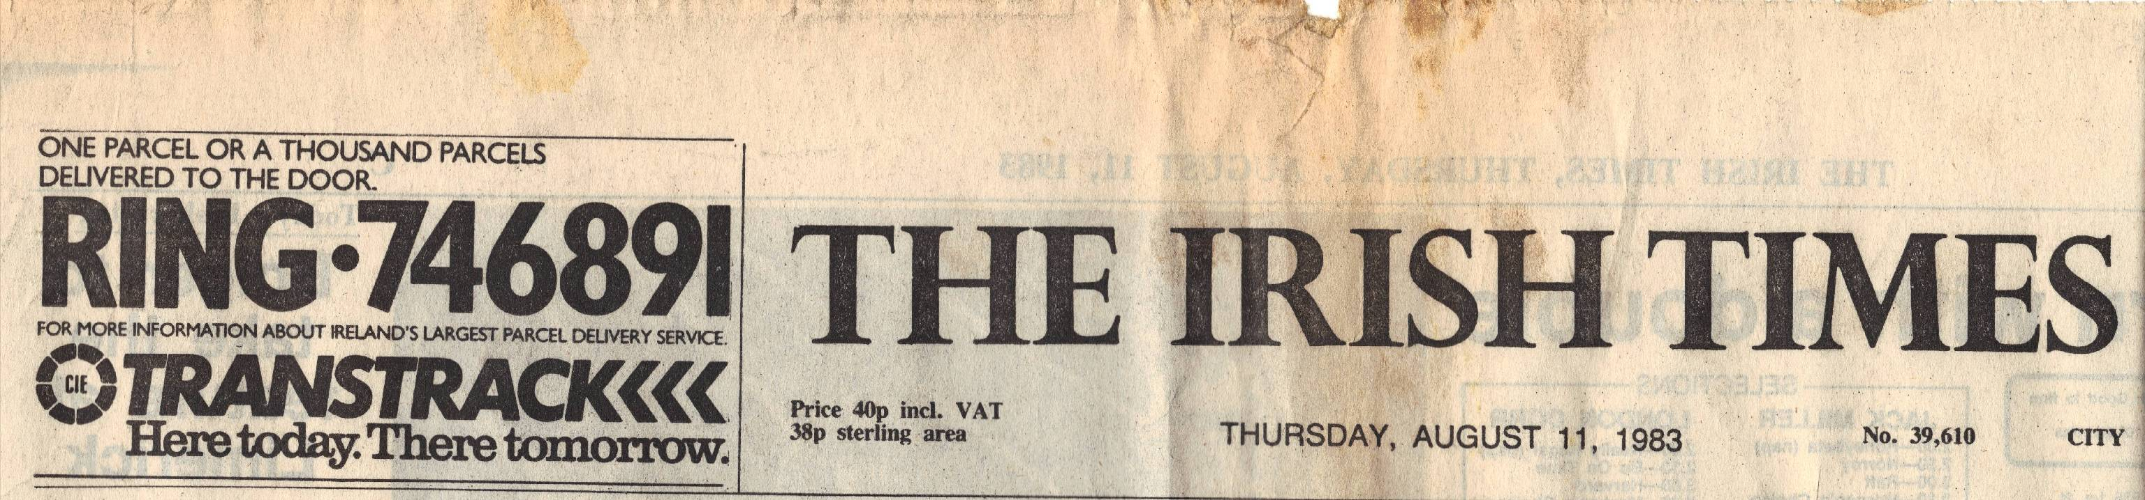
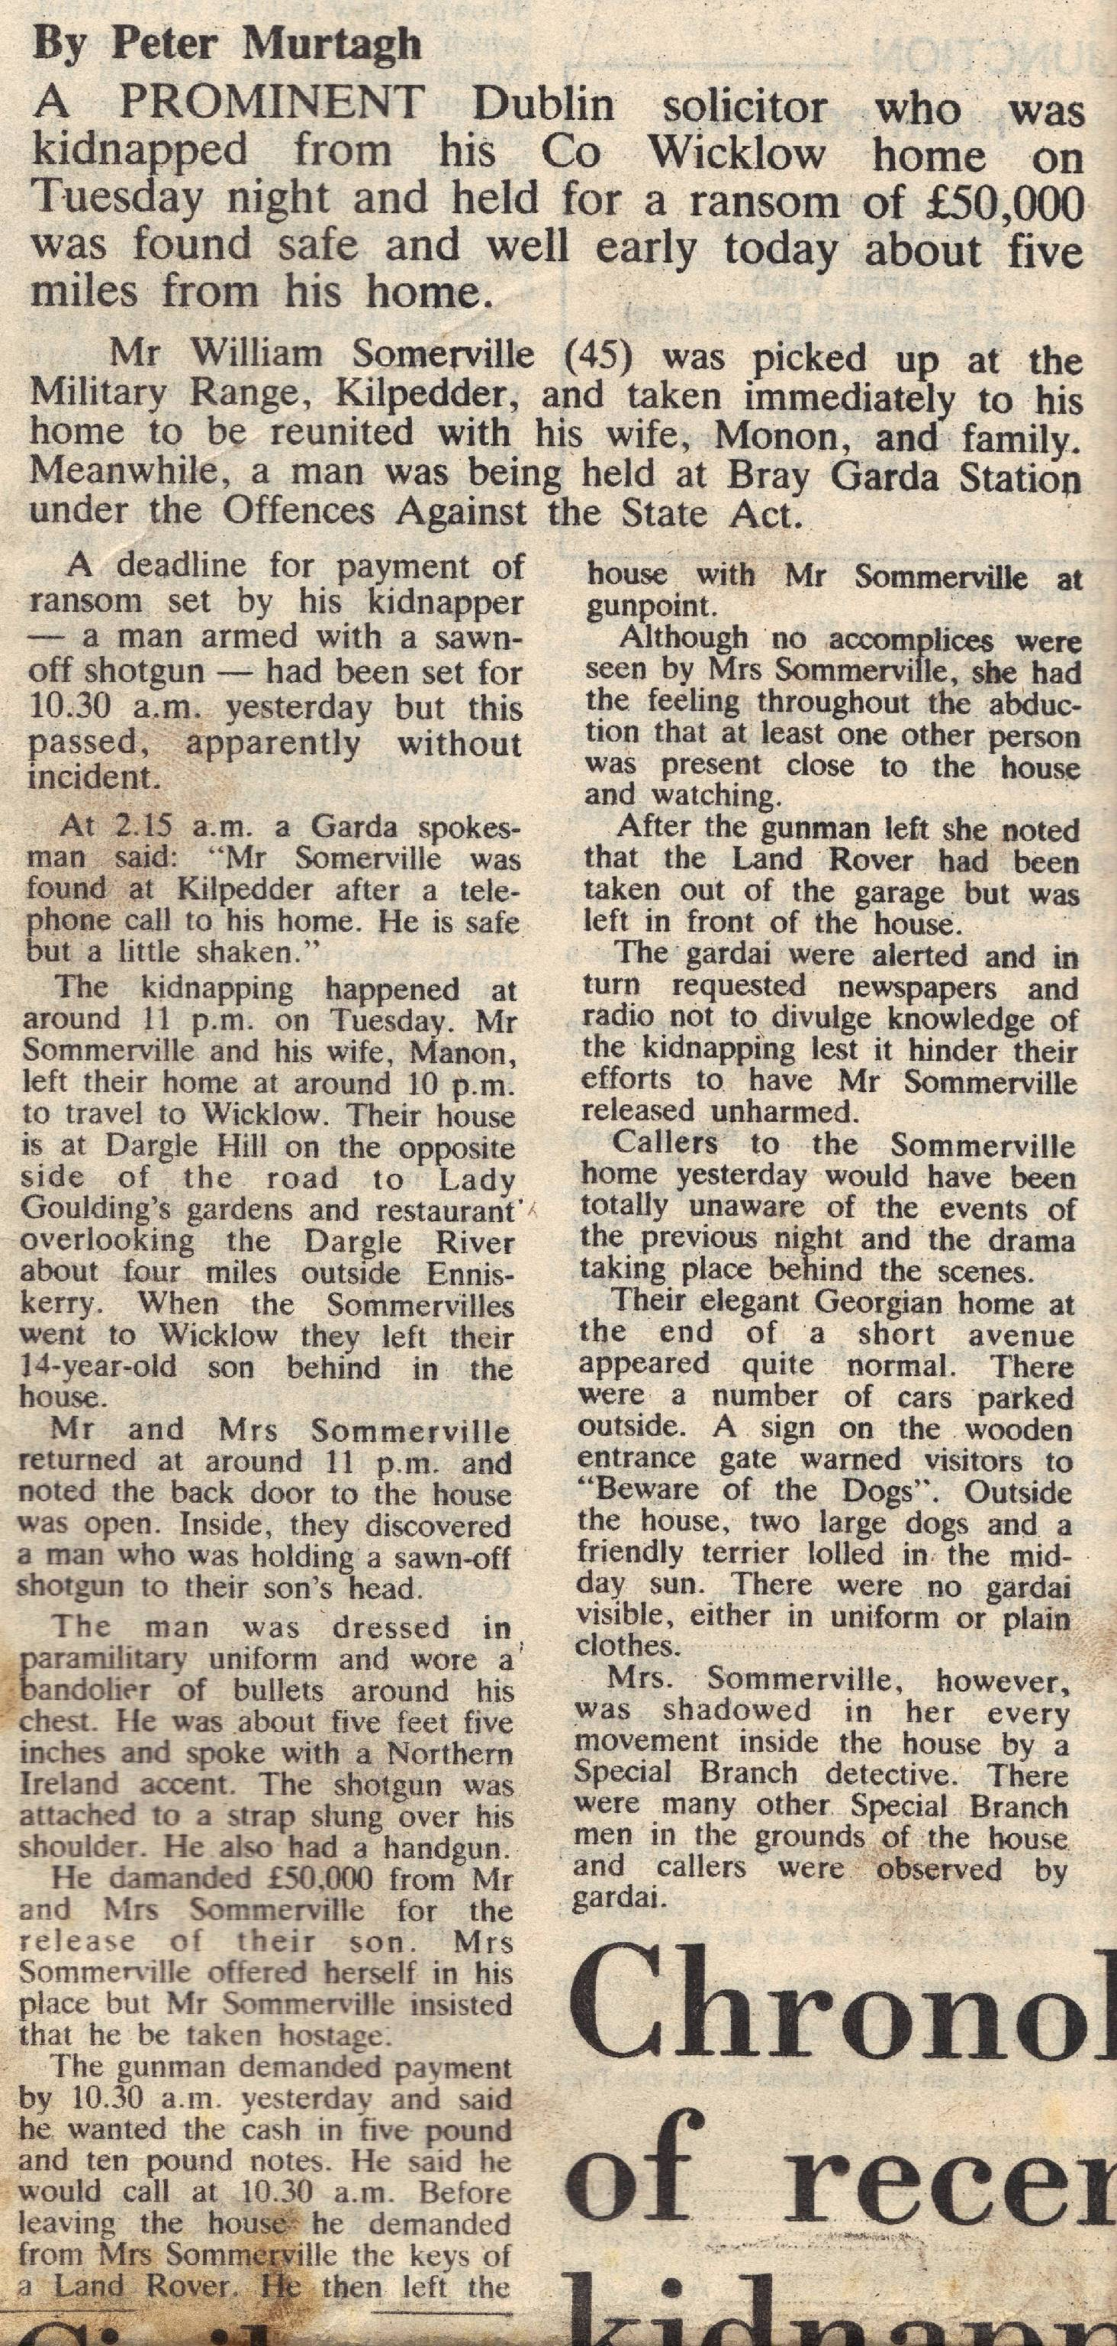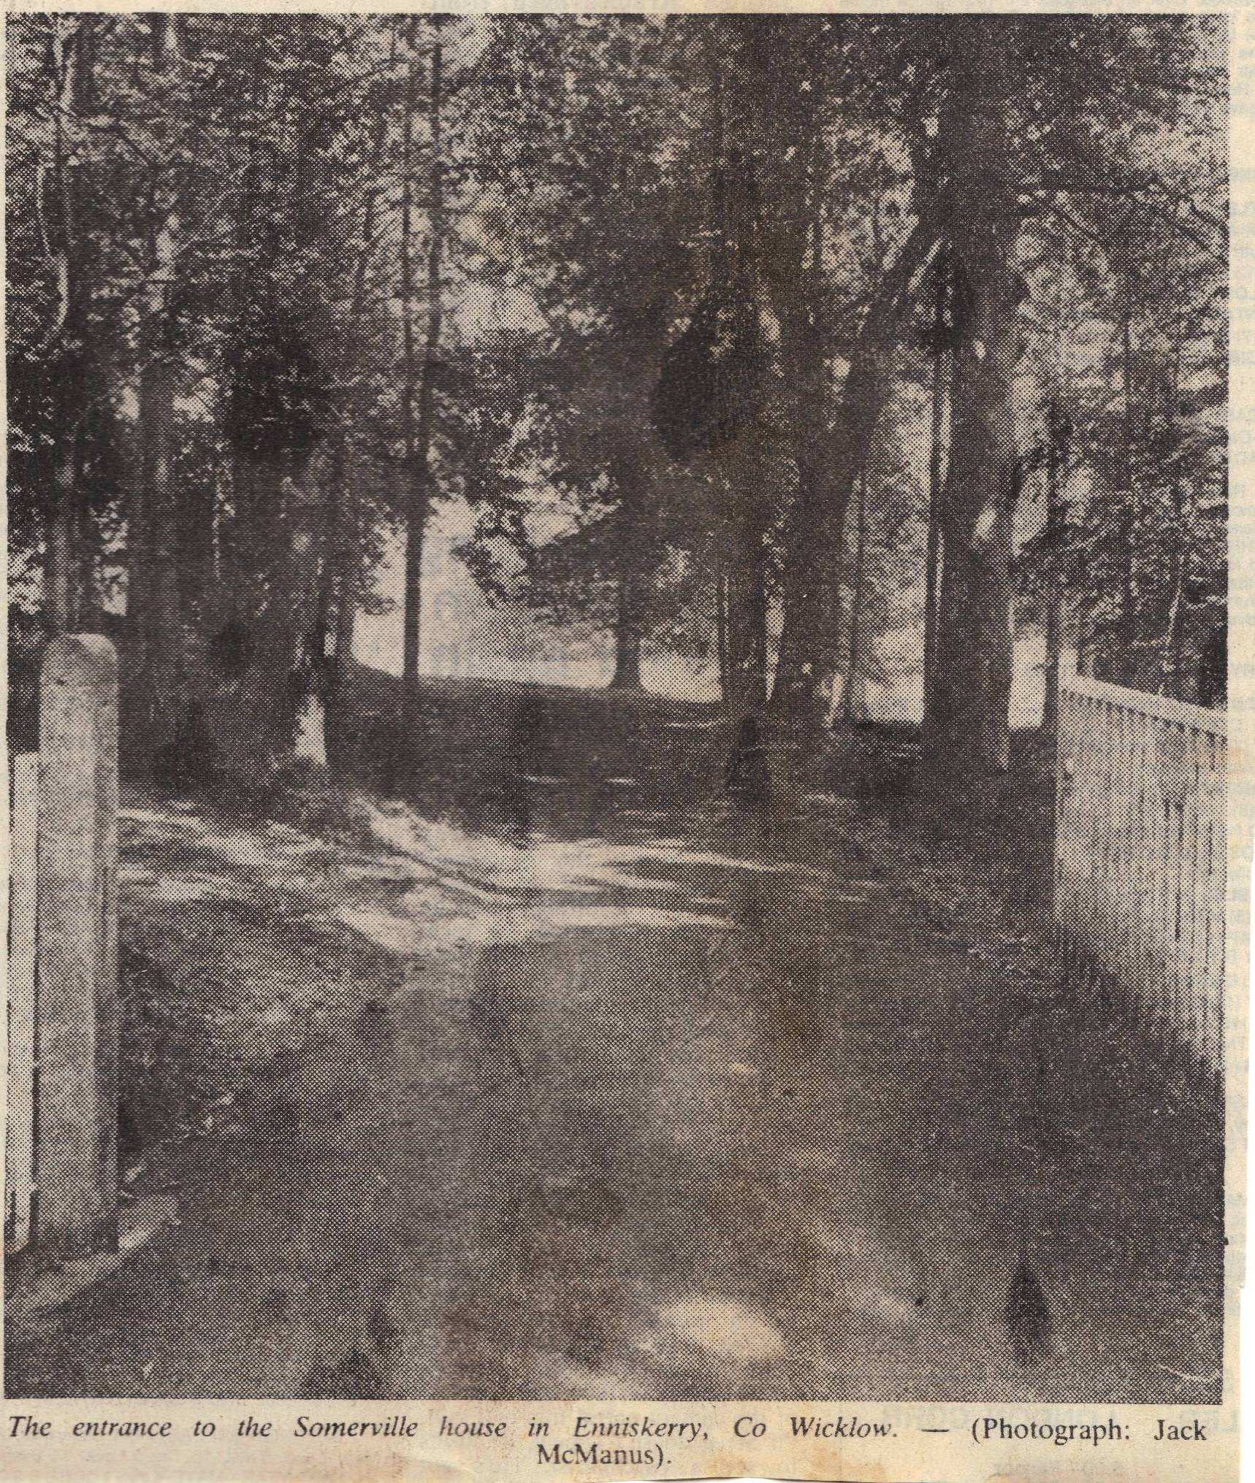

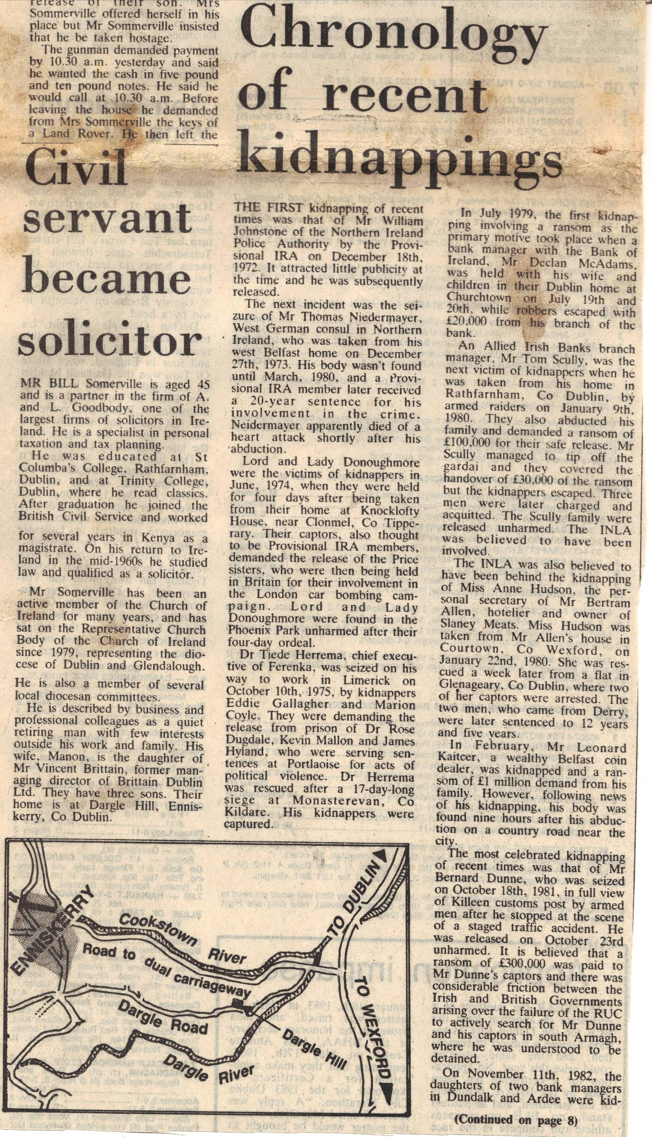

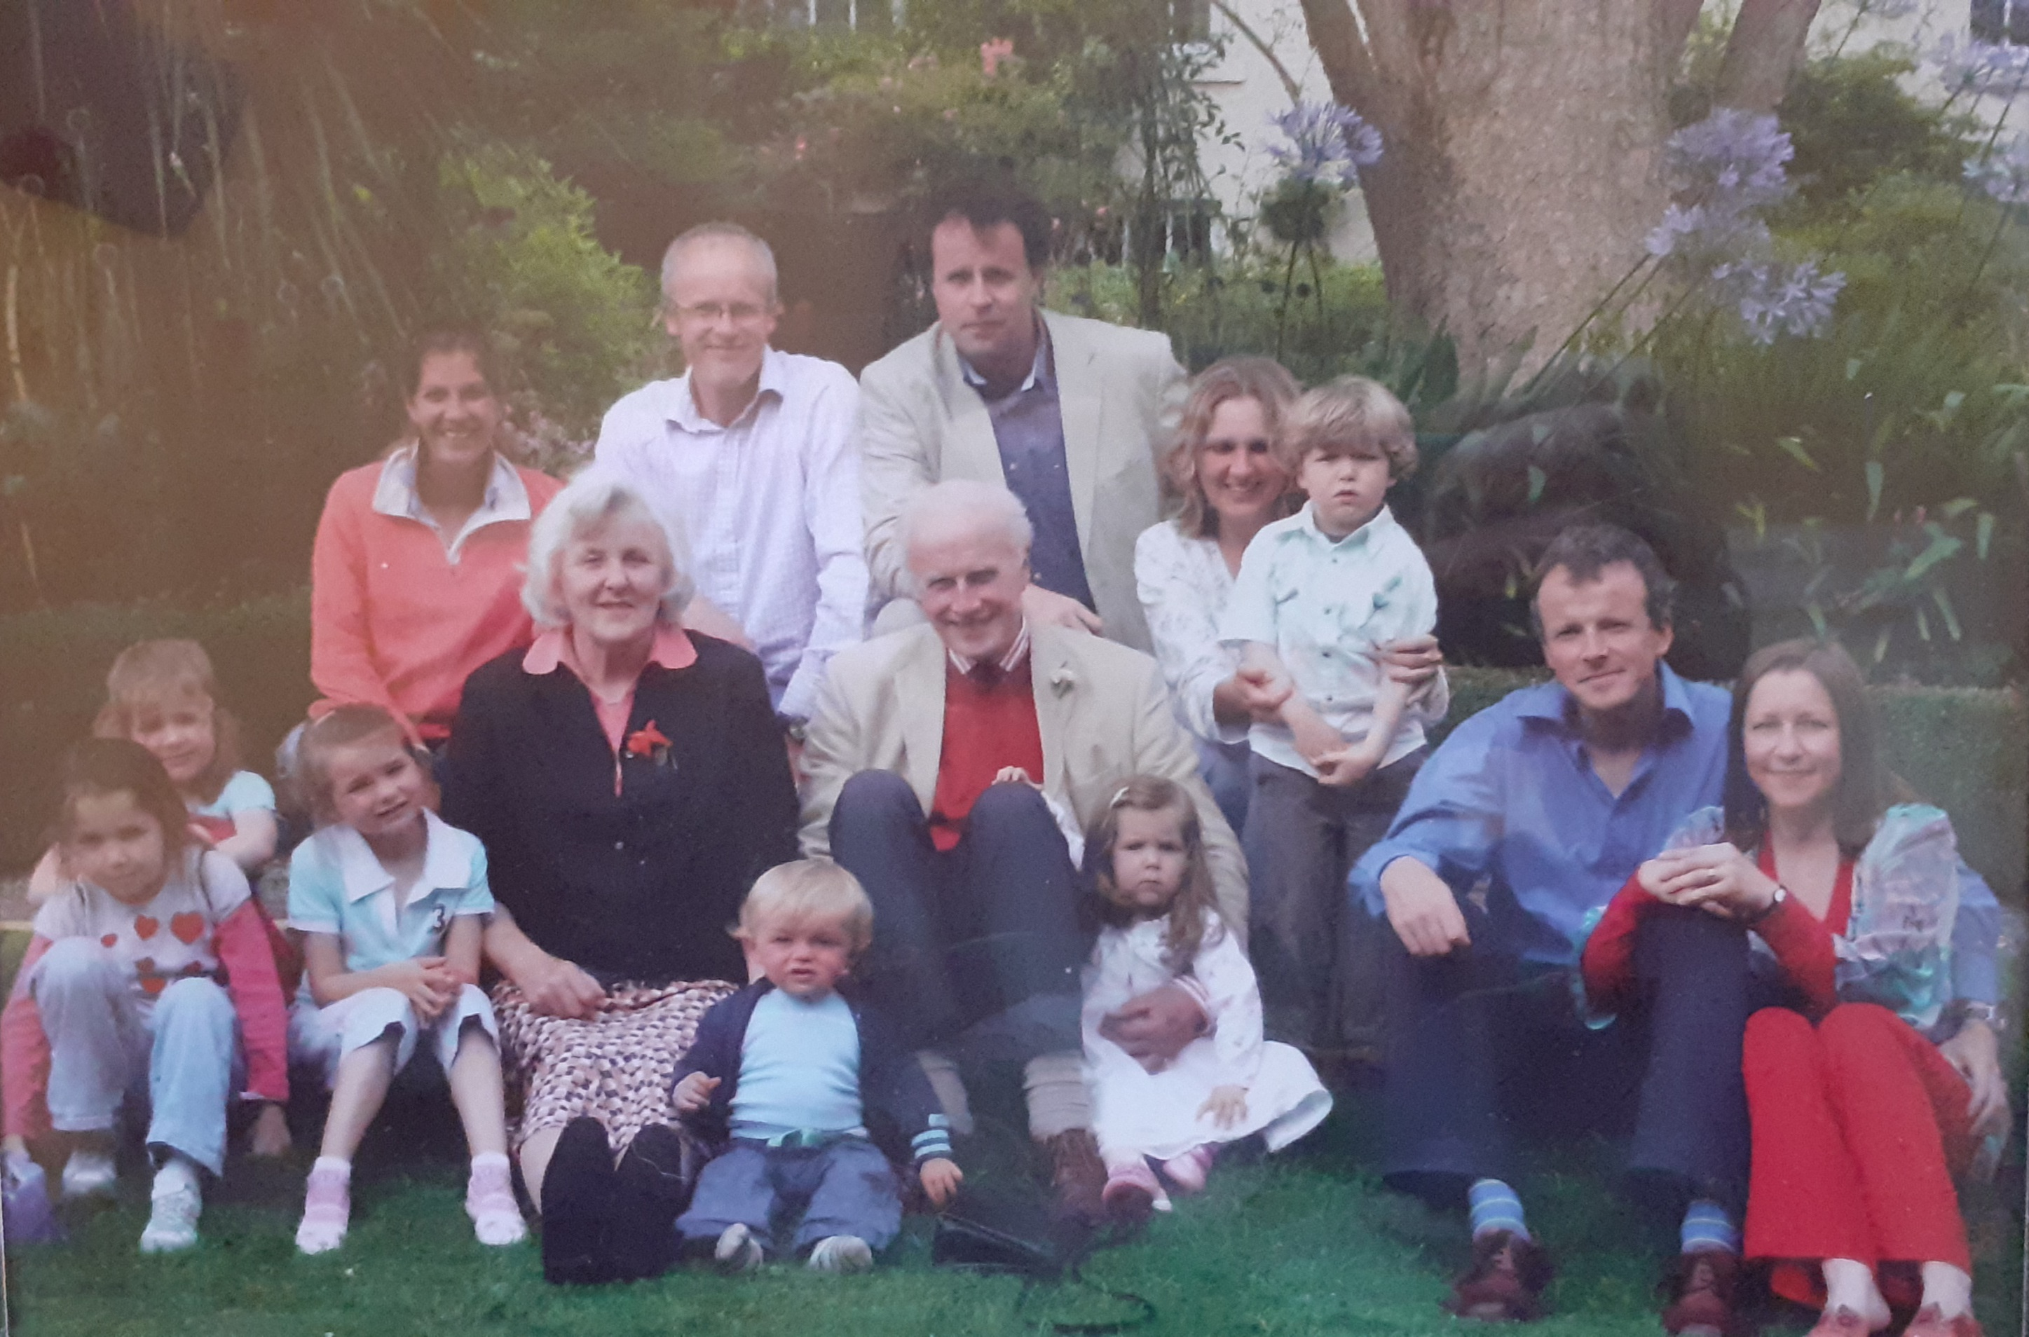

Family of Bill and Manon taken at Hunters Hotel in 2008 after a lunch to celebrate Bill and Manon’s 40th Wedding Anniversary.
Back Row: Ruth, Edward, Charles Adrienn with Gergely.
Next Row: Manon and Bill.
Front Row:Eliza with Poppy behind, Georgia, Alexander, Beatrice James and Holly.
Benedek had not yet been born.

